EXPERIMENT VII

Aim: The aim is to trial different app layouts and color schemes and evaluate user feedback on aesthetics and usability using GIMP.

PROCEDURE:
Tool Link: https://www.gimp.org/
Step 1: Install GIMP
● Download and Install: Download GIMP from GIMP Downloads and install it on your computer.
Step 2: Create a New Project
- Open GIMP:
- Launch the GIMP application.
2. Create a New Canvas:
- Go to File -> New to create a new project.
- Set the dimensions for your app layout (e.g., 1080x1920 pixels for a standard mobile screen).
Step 3: Design the Base Layout
- Create the Base Layout:
- Use the Rectangle Select Tool to create sections for different parts of your app (e.g., header, content area, footer).
- Fill these sections with basic colors using the Bucket Fill Tool.
- Example Output: A base layout with defined sections for header, content, and footer.
- Add UI Elements:
- Text Elements: Use the Text Tool to add text elements like headers, buttons, and labels.
- Interactive Elements: Use the Brush Tool or Shape Tools to draw buttons, input fields, and other interactive elements.
- Example Output: A layout with labeled sections and basic UI elements.
- Organize Layers:
- Use layers to separate different UI elements. This allows you to easily modify or experiment with individual components.
- Name each layer according to its content (e.g., Header, Button1, InputField).
Step 4: Experiment with Color Schemes
- Create Color Variants:
- Duplicate Layout: Duplicate the base layout by right-clicking on the image tab and selecting Duplicate.
- Change Colors: Use the Bucket Fill Tool or Colorize Tool to change the colors of the UI elements in each duplicate.
- Example Output: Multiple color variants of the same layout.
- Save Each Variant:
- Save each color variant as a separate file (e.g., Layout1.png, Layout2.png etc.).
- Go to File -> Export As and choose the file format (e.g., PNG).

Step 5: Collect User Feedback
- Prepare a Feedback Form:
- Create Form: Create a feedback form using tools like Google Forms or Microsoft Forms.
- Include Questions: Include questions about the aesthetics and usability of each layout and color scheme.
- Share the Variants:
- Distribute Files: Share the image files of the different layouts and color schemes with your users.
- Provide Instructions: Provide clear instructions on how to view each variant and how to fill out the feedback form.
- Gather Feedback:
- Collect responses from users regarding their preferences and suggestions.
- Analyze the feedback to determine which layout and color scheme are most preferred.
Step 6: Iterate and Refine
- Refine the Design:
- Based on the feedback, make necessary adjustments to the layout and color scheme.
- Experiment with additional variations if needed.
- Final Testing:
- Conduct a final round of testing with the refined design to ensure usability and aesthetic satisfaction.

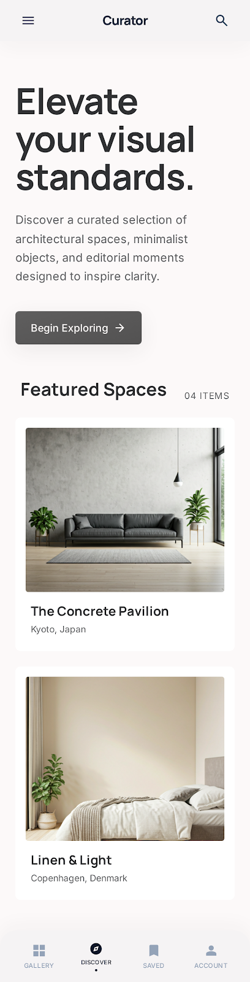
STEP 1

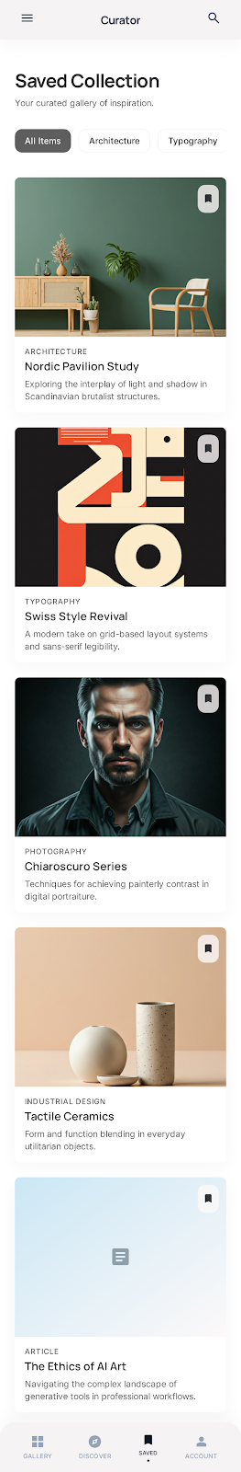
STEP 2

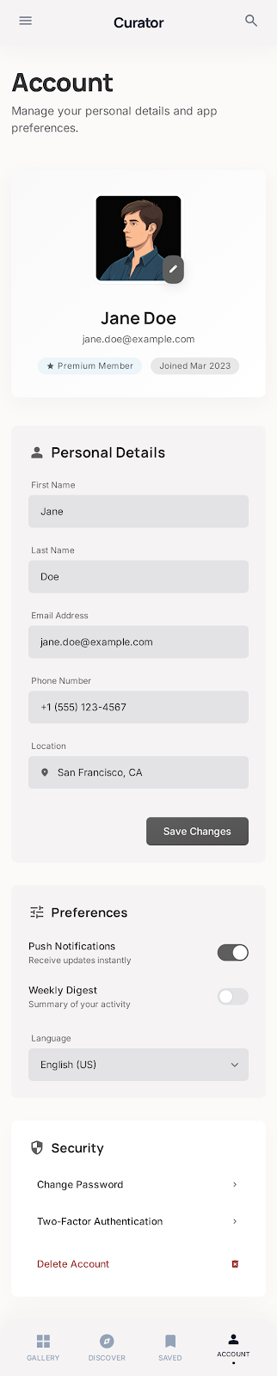
STEP 3


STEP 4

